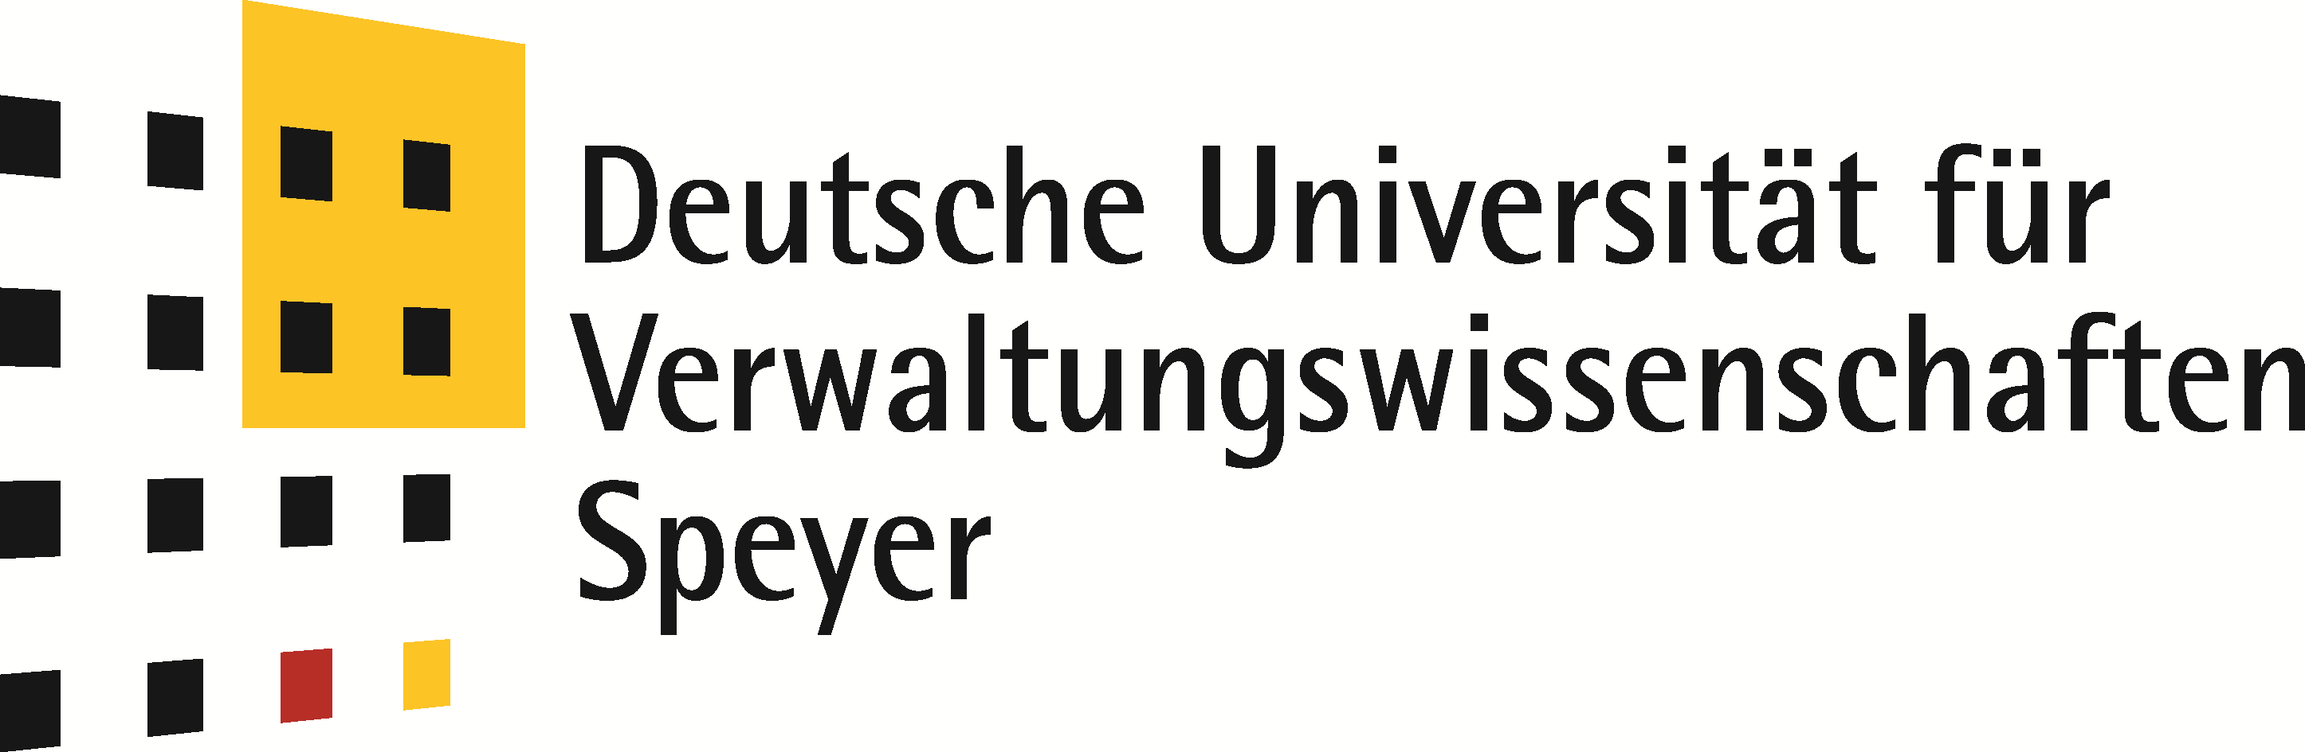
Application for international students
Speyer University/SPEA program 2014 “SPEA on the Rhine”
- the program runs from 13 May to 13 June 2014 -
(arrival day in Germany is on Monday, 12 May, departure is between 13 and 15 June 2014)
Please fill in in block letters, scan it and mail it by 15 January 2014 at the latest to:
Prof. Dr. Dr. h.c. Andreas Knorr
knorr@uni-speyer.de

I hereby apply to participate in the program “SPEA on the Rhine”
13 May – 13 June 2014
1. Surname: ____________________________
2. First name: __________________________
3. Date of birth: __________________________
4. Place of birth: __________________________
5. Gender: __________________________
6. Nationality: __________________________
7. Main residence
________________________________________________________________
(Country) (City with zip code)
________________________________________________________________
(Street name, no.) (Phone and/or mobile phone no)

8. E-Mail address: ___________________________

9. Residence during your stay in Speyer
- Double bedroom in dormitory requested yes no
- Other address:
________________________________________________________________
________________________________________________________________

10. Major studies (Number of university semesters, fields of study):
________________________________________________________________
________________________________________________________________
________________________________________________________________

11. University degrees:
________________________________________________________________
________________________________________________________________
________________________________________________________________
12. Required documents (to be attached)
- Copy of bachelor or master degree
- For Undergraduates: please submit your class rank (evidence that you are in the top third of your class)
- Proof of medical insurance valid in Germany (can be sent at a later date)

………………………………………………………………………………………………………………………..
City, date Signature

